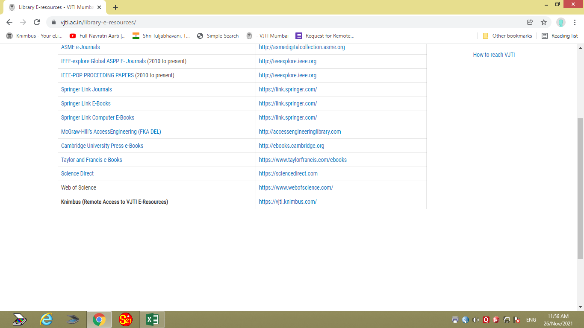

Kindly put the following on a new line, below Knimbus (remote Access…) the following:

For Knimbus Registration | https://vjti.knimbus.com/user#/home

